CHAROTAR UNIVERSITY OF SCIENCE & TECHNOLOGY
Chandubhai S Patel Institute of Technology
V.T. Patel Department of Electronics & Communication

Report Summary

One Day Workshop
On
CMOS Integrated Circuit Design Using Cadence

Dates : - 23rd February, 2024
No. of Participants: - 20
Students
20

Resource Person: 1.Dr.Arpita Patel.
Associate professor, EC Department, CSPIT, CHARUSAT

Brief of Workshop:
VLSI Design has become an important domain in the field of Digital and Analog circuits. The aim of this workshop is to provide a basic knowledge of design concepts in VLSI Design and motivate the students towards research in the field of VLSI. This workshop provides the knowledge of Cadence EDA tool, and also provides hands on exposure to key features and aspect of Virtuoso Schematic Editor, Analog Design Environment, Virtuoso layout suite and Virtuoso Spectre Simulator.
Following content were covered:
The workshop would cover following:
1. Understanding Cadence Design Suite
2. Design & Simulation using Cadence Virtuoso-Hands-on
3. Layout Design and Simulation-Hands-on
4. Process Variation, Corner Analysis and Monte Carlo Simulations-Hands-on

Workshop was concluded with the feedback of participants.

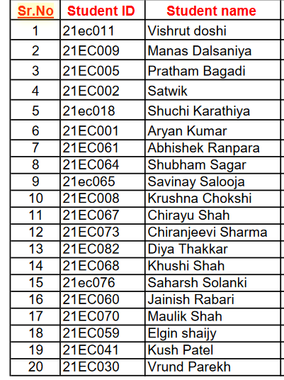

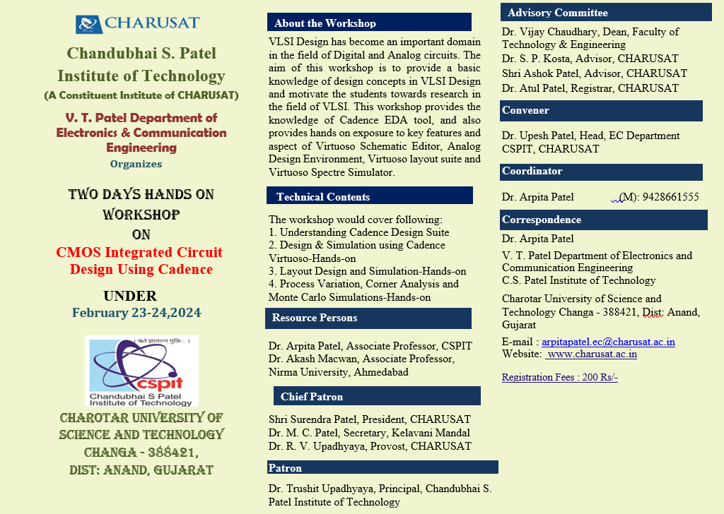
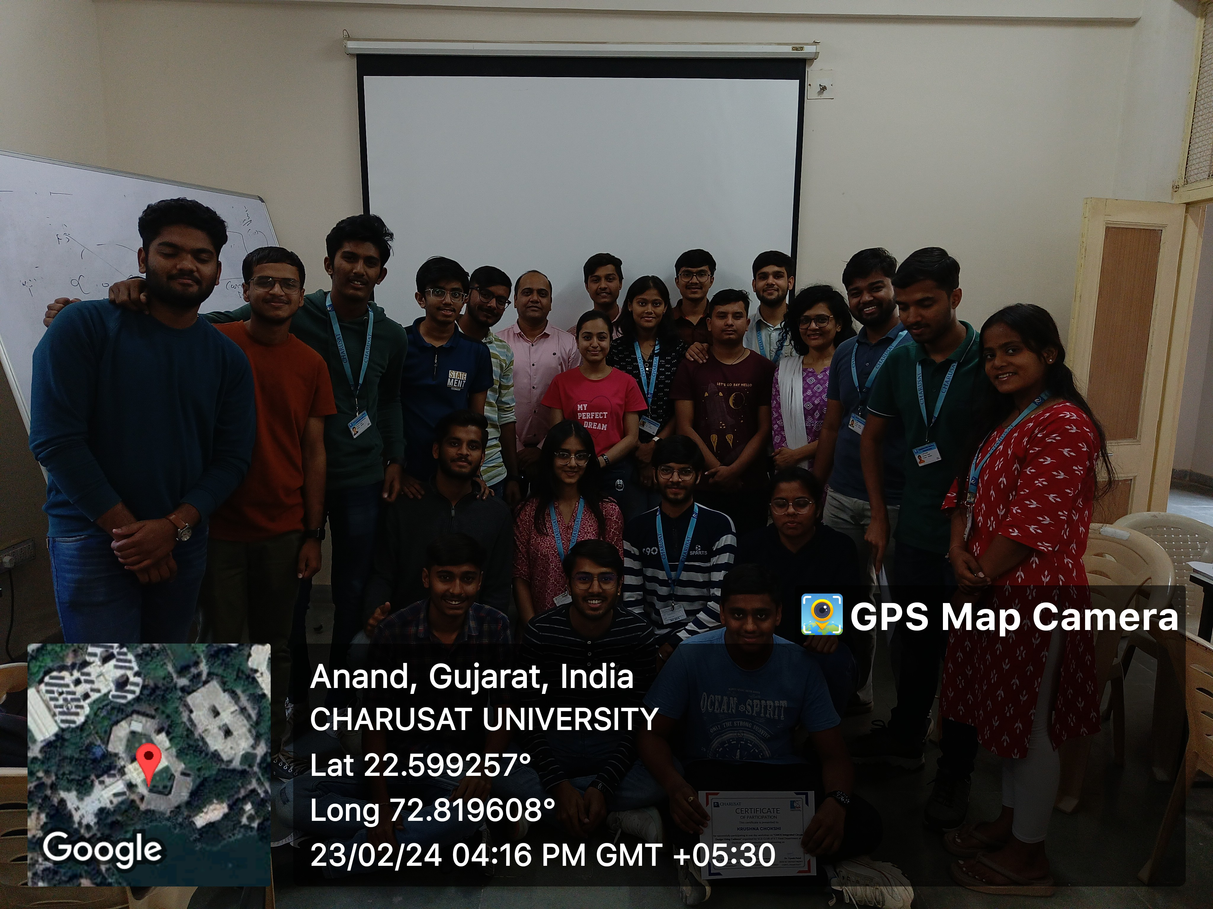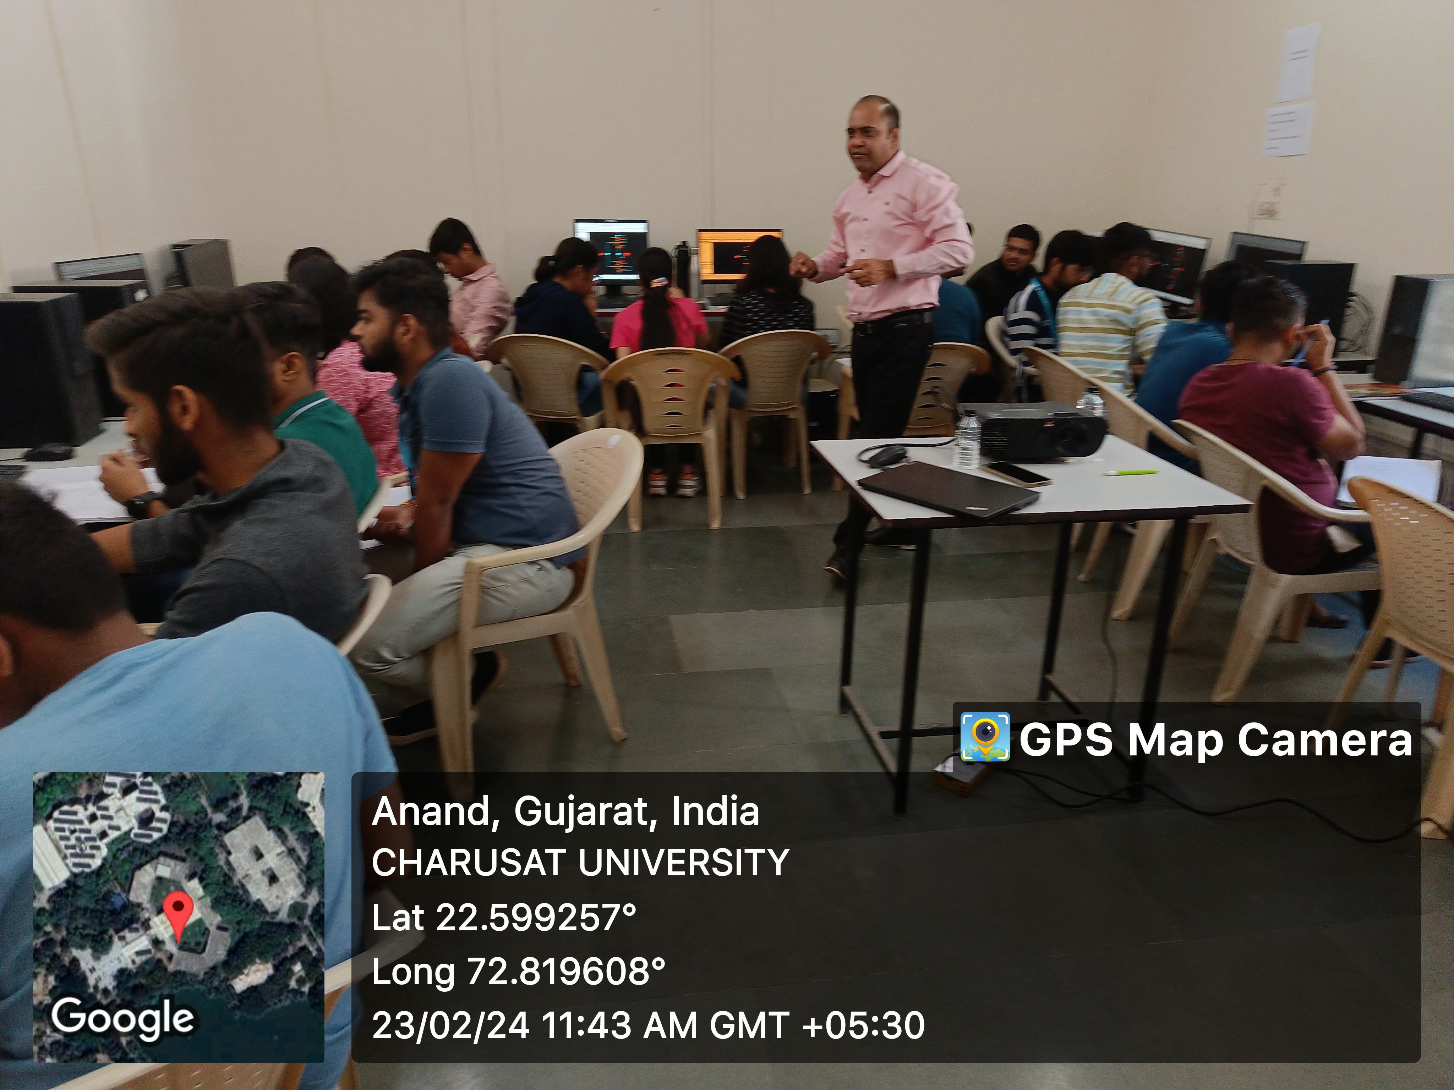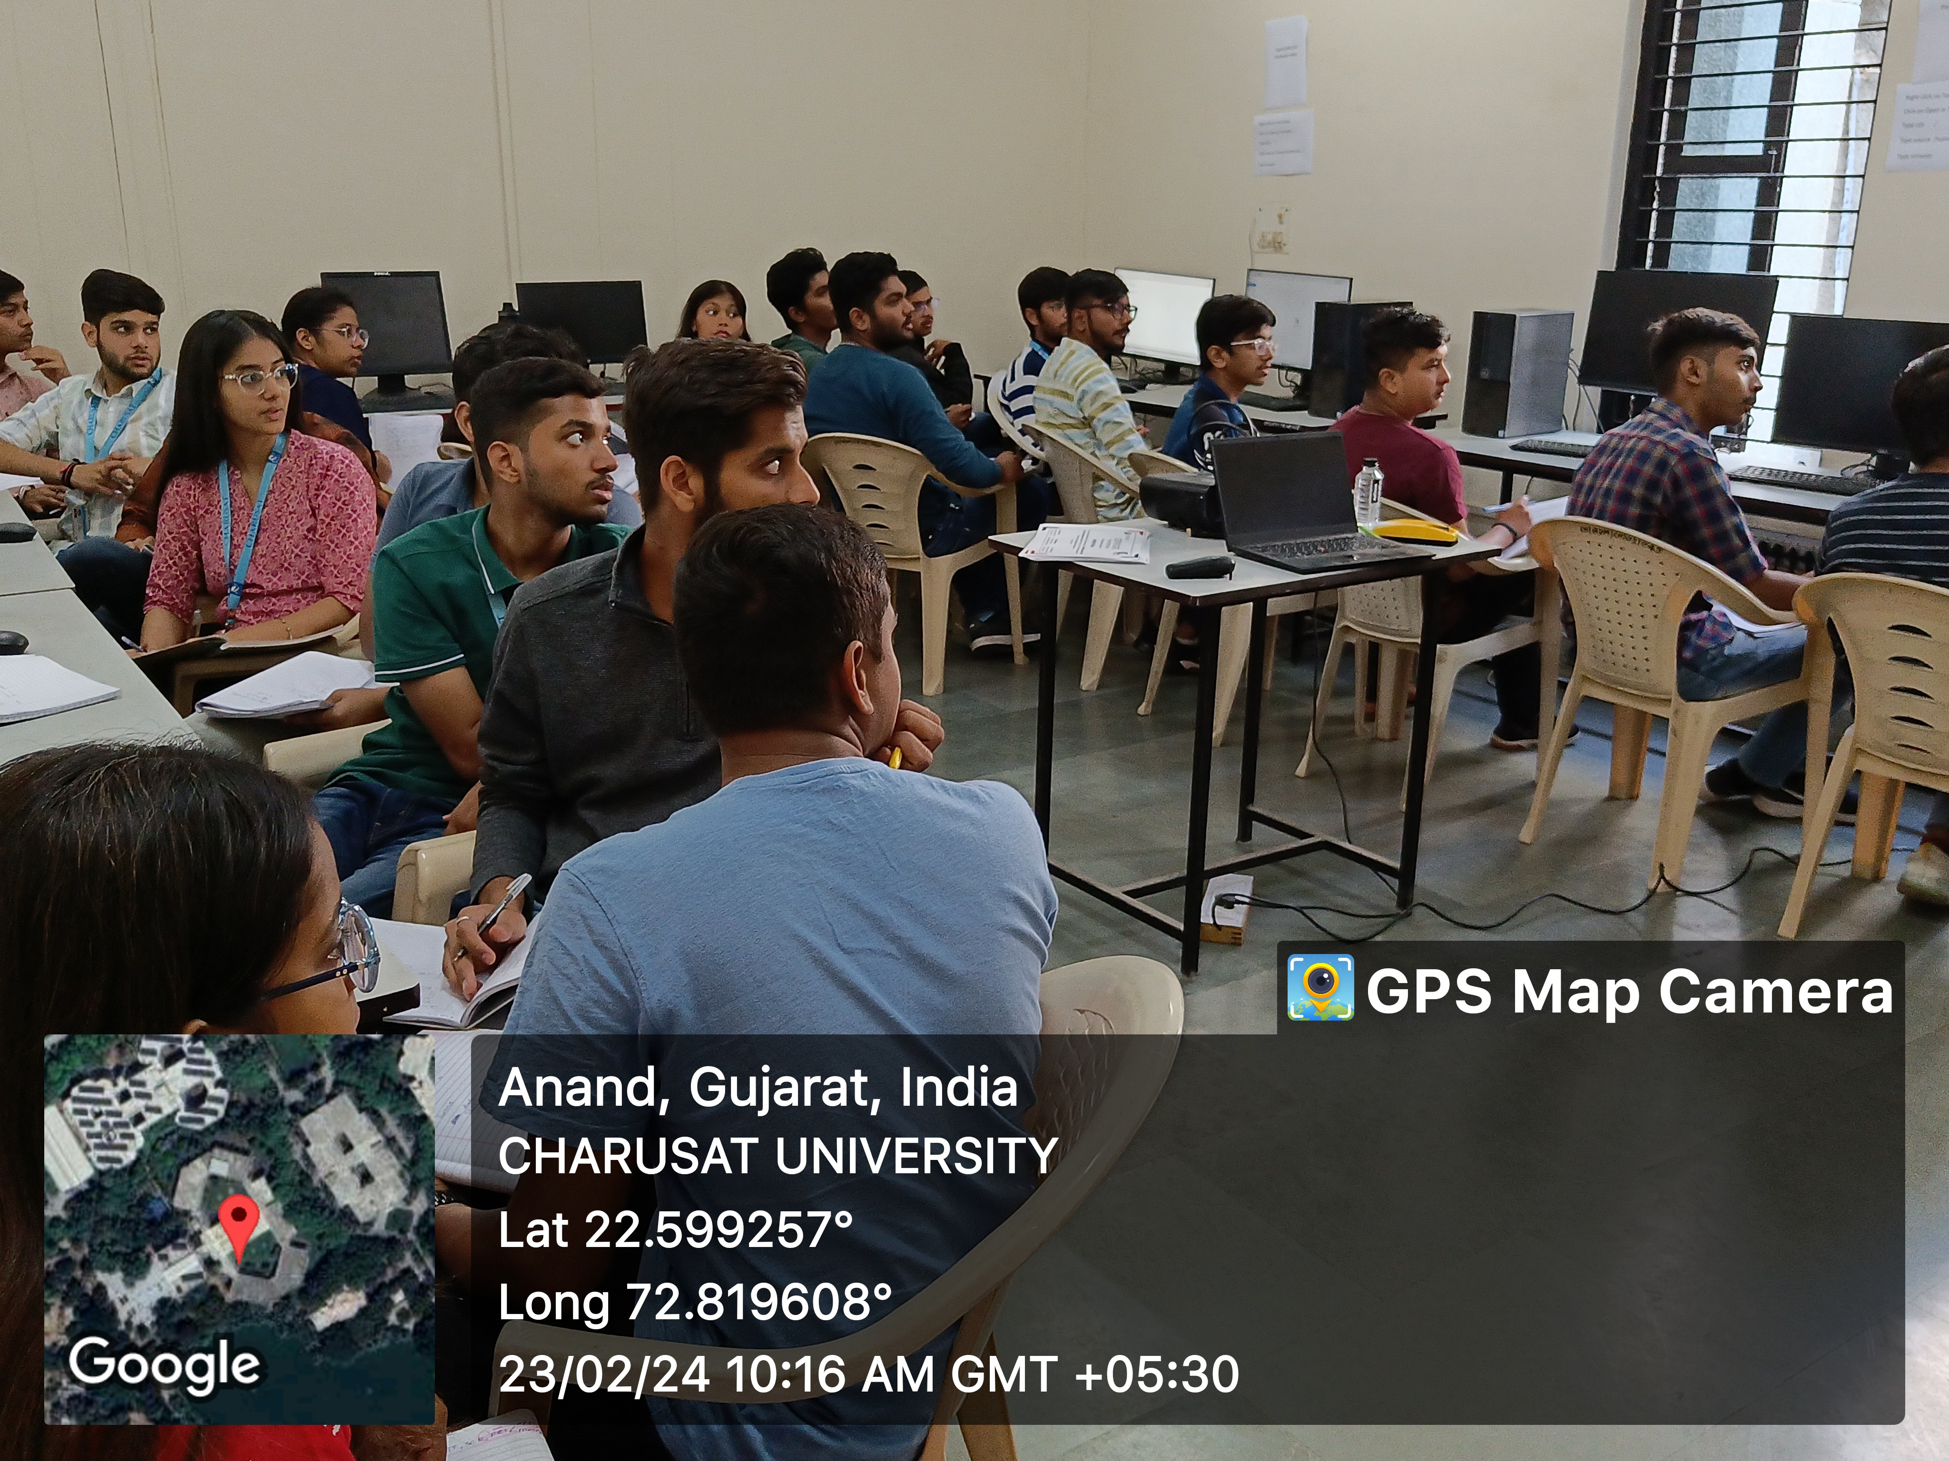

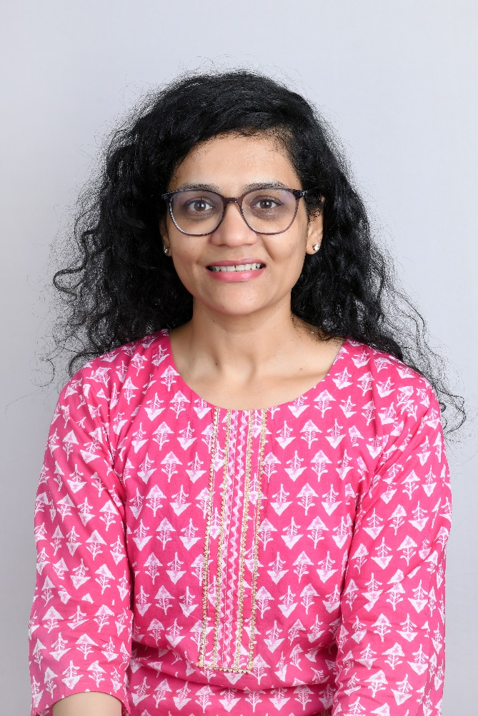
Dr.Arpita Patel
Associate Professor
Ph.D
VLSI,Wireless

